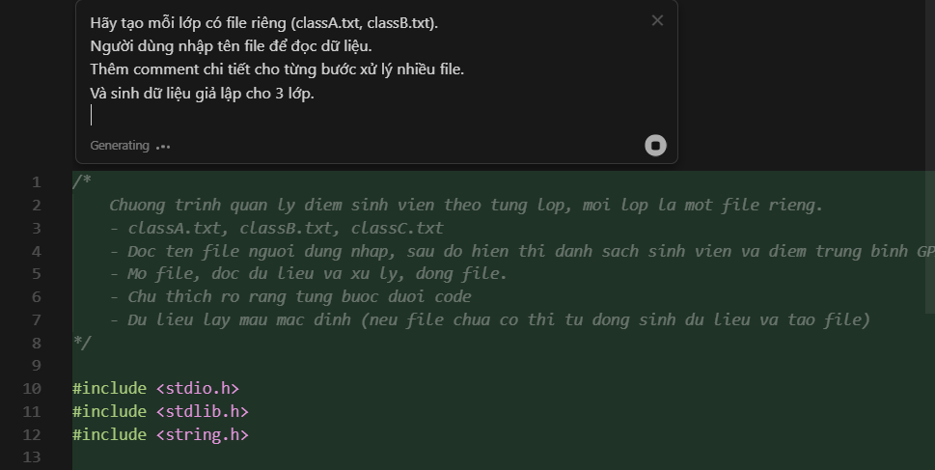
Code trả về:
#include <stdio.h>
#include <stdlib.h>
#include <string.h>

// --- Khai bao cau truc sinh vien ---
typedef struct {
int id;
char name[50];
int age;
float gpa;
} Student;

// --- Ham tinh GPA trung binh cua mot mang sinh vien ---
float calculateAverageGPA(Student studentList[], int studentCount) {
if (studentCount == 0) return 0.0f;
float totalGPA = 0.0f;
for (int i = 0; i < studentCount; i++) {
totalGPA += studentList[i].gpa;
}
return totalGPA / studentCount;
}

// --- Ham in danh sach sinh vien ---
void printStudentList(Student studentList[], int studentCount) {
printf("%-6s %-10s %-5s %-5s\n", "ID", "Name", "Age", "GPA");
printf("-------------------------------------\n");
for (int i = 0; i < studentCount; i++) {
printf("%-6d %-10s %-5d %-5.2f\n",
studentList[i].id,
studentList[i].name,
studentList[i].age,
studentList[i].gpa);
}
}

// --- Ham tao du lieu gia lap cho lop ---
void generateSampleDataIfNeeded(const char* filename) {
FILE* f = fopen(filename, "r");
if (f != NULL) { // Da co file, khong can tao nua
fclose(f);
return;
}
// Neu chua co file, tao file va ghi du lieu gia lap
f = fopen(filename, "w");
if (!f) {
printf("Khong the tao file du lieu: %s\n", filename);
return;
}
// Moi lop co 5 sinh vien vi du (id, name, age, gpa)
// Ghi du lieu dua theo lop
if (strstr(filename, "classA")) {
fprintf(f, "2001 Alice 18 2.7\n2002 Bob 19 3.1\n2003 Carol 18 3.5\n2004 David 20 2.8\n2005 Eva 19 3.0\n");
} else if (strstr(filename, "classB")) {
fprintf(f, "2101 Max 20 3.8\n2102 Lily 20 3.0\n2103 Tom 21 2.5\n2104 Emma 19 3.2\n2105 Nick 21 3.4\n");
} else if (strstr(filename, "classC")) {
fprintf(f, "2201 Jack 18 2.6\n2202 Rose 18 2.9\n2203 Julia 19 2.4\n2204 Peter 20 3.5\n2205 Sam 19 3.9\n");
} else {
// Neu file la ten khac, tao du lieu mac dinh
fprintf(f, "3001 Test1 18 3.0\n3002 Test2 19 2.8\n");
}
fclose(f);
}

// --- Ham doc danh sach sinh vien tu file ---
int readStudentListFromFile(const char* filename, Student* arr, int maxStudents) {
FILE* f = fopen(filename, "r");
if (!f) {
printf("Khong the mo file: %s\n", filename);
return 0;
}
int n = 0;
// Doc tung dong du lieu (id name age gpa)
while (n < maxStudents &&
fscanf(f, "%d %49s %d %f",
&arr[n].id, arr[n].name, &arr[n].age, &arr[n].gpa) == 4) {
n++;
}
fclose(f);
return n; // so luong sinh vien doc duoc
}

// -------- Ham xu ly chinh -------------
void processClassFromFile() {
char filename[100];
printf("Nhap ten file du lieu lop (vi du: classA.txt): ");
scanf("%99s", filename);

// Tao du lieu mau neu file chua ton tai
generateSampleDataIfNeeded(filename);

// Khai bao mang sinh vien (toi da 100 ban)
Student students[100];
// Doc du lieu tu file vao mang
int count = readStudentListFromFile(filename, students, 100);

// Neu khong co du lieu thi thoat
if (count == 0) {
printf("Khong co du lieu sinh vien trong file!\n");
return;
}
printf("\n=== DANH SACH SINH VIEN LOP trong %s ===\n", filename);
printStudentList(students, count);

// Tinh GPA trung binh & hien thi
float avg = calculateAverageGPA(students, count);
printf("\nGPA trung binh cua lop %s la: %.2f\n", filename, avg);
}

int main() {
processClassFromFile();
return 0;
}
